EX NO : 9 DEPLOYMENT OF HONEYPOTS AND ANALYSIS ROLL NO : 231901027

DATE : 16.04.2025 OF BOTNET ACTIVITIES

AIM:

A guided room covering the deployment of honeypots and analysis of botnet activities TASK 2 : TYPES OF HONEYPOTS



TASK 3 : COWRIE DEMO

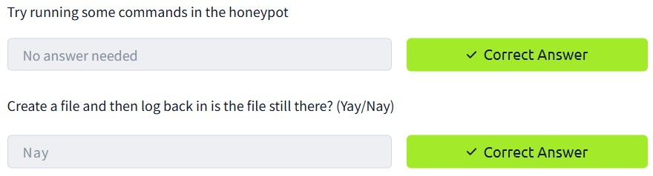

TASK 4 : COWRIE LOGS

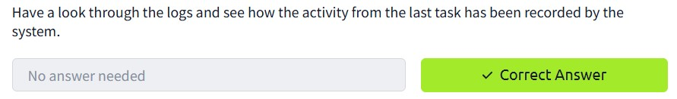

TASK 5 : ATTACKS AGAINST SSH

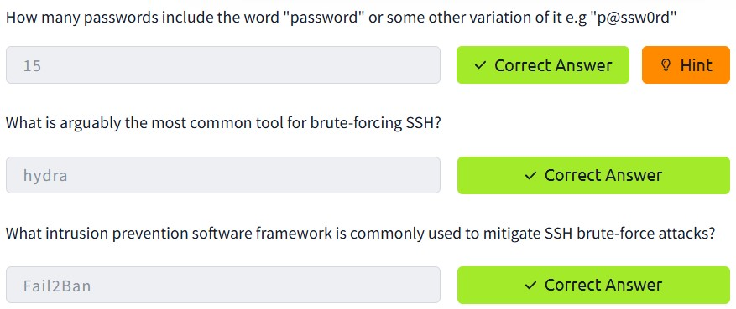

TASK 6 : TYPICAL BOT ACTIVITY

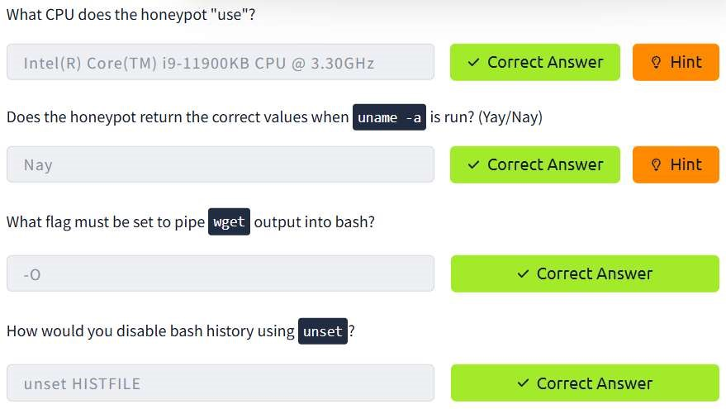

TASK 7 : IDENTIFICATION TECHNIQUES

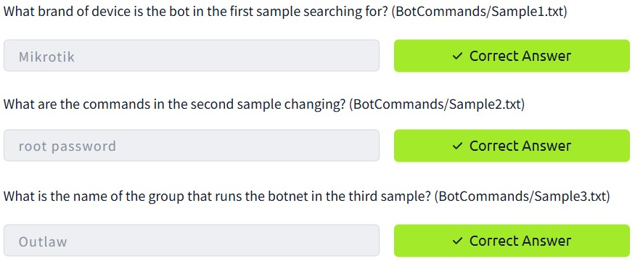

TASK 8 : SSH TUNNELLING

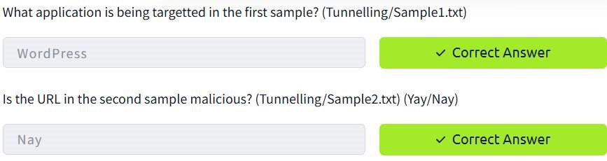

CONCLUSION :

Honeypot and analysis of botnet activities is successfully deployed.